Strategies to use Natural Growth Promoters and antibiotics

Mickael ROUAULT, Poultry Technical Manager, BIOMIN

Nowadays, Natural Growth Promoters (NGP) are commonly included in feed and water for poultry. The objective is to prevent gut diseases, to enhance performances and also to decrease the medication costs. NGP are promoted as potential substitutes to antibiotics, which are used for treatments or as growth promoters. They are actually tested against each other but few strategies are suggesting their combination during a production cycle.
Since the 1940’s, antibiotics have been used in poultry feeds as growth promoters (AGP) or as a treatment against diseases through the feed and water. An AGP is included in feed to improve performance and to control sub-clinical gut infections, whereas an antibiotic treatment is solving an identified disease (AVCARE, 2003). Antibiotics are chemotherapeutic agents which kill or inhibit gram positive and/or gram negative bacteria. These substances can have a particular target or a broad-spectrum that affects a wide range of bacteria.
The use of antibiotics, their residues in food and the resistance of some pathogens (ie, Salmonella, Campylobacter, E.Coli, among others) in animals and humans turned into a topic of tremendous interest the recent decades. While antibiotic was a great discovery for animal production in the 1940’/1950’s (AVCARE, 2003), in the late 1990’s in Europe, it was becoming clear that the pressure to remove AGPs was gradually increasing (Woodward, 2005). AGP have even been banned by the European Union since 2006 in feed and also by an important fast-food chain in USA. Unfortunately, in animal production and especially in poultry, the misuse and the overuse of antibiotics have lead to the emergence of bacteria resistances in animals.
The restriction on the use of AGP when implemented resulted in a negative impact on live broiler performance. In this situation, litter conditions and the control of enteric disease were more difficult to manage (Woodward, 2005).
Feed quality and farm management improved in an attempt to keep birds in good health and high performances. NGP became a realistic option to substitute, at least partially, the ban or the decrease of antibiotic use.
NGP have always been presented against antibiotics as a replacement option to improve live performances. Few articles have mentioned the potential for complementary or supplementary combinations between these two categories of feed additives. Many solutions are available as NGP such as probiotics, essential oils, plant extracts, organic acids, prebiotics and enzymes. Both antibiotics and NGP have the capacity to balance the gut bacterial flora, to reduce the nutrients available for pathogens, to improve growth performances and feed efficiency, to improve food safety, and finally to enhance animal welfare by decreasing all kind of stresses (Cervantes, 2009; Steiner, 2006). On the other hand, their mode of action can be very different. The focus is done in the following lines on some examples of combination between antibiotics and NGP.

PROBIOTICS and antibiotics
Probiotics are bacteria (Probiotic products are single or mixed strains) which establish a balanced gut flora (Fuller, 1989) in terms of quantity and quality but also in some cases diversity. Probiotics are able to exclude the colonization of pathogens in the gut of poultry (Griggs, 2005), producing antimicrobial substances and stimulating the immune system (Perdigon et al., 2001). They are recommended the very first days and around digestive stresses such as feed changes, vaccination or antibiotic treatment. Performances can be improved considering these modes of action. By applying a multi-strain probiotic in drinking water at 3 periods in the production cycle of broilers (1-3 days of age, 10-12 days, 18-20 days), Mohnl (2006) showed an improvement of 94g of weight gain at 40 days and an improvement of 0.04 for the feed conversion (FCR).
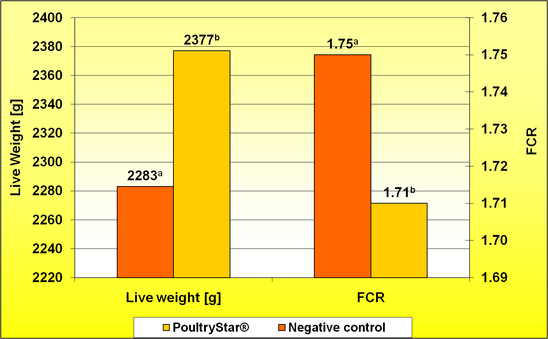
Antibiotic kills or inhibits bacteria but it cannot establish a beneficial flora like a probiotic.
In this case, the probiotic will be applied during the very first days through water application. By definition, an antibiotic treatment should not be applied at the same time in the water.
The presence of an AGP in the feed at the same time, is not necessarily contradictory. In fact it can be possible that the level of antibiotic in the feed is low and that the quantity of probiotics (cfu/g product) is provided in a sufficient amount.
As a complementary combination, the right and most effective probiotics can also be used through the water to fight Clostridium perfringens and necrotic enteritis in the gut (McReynolds et al., 2008). Another option is to apply probiotics after an antibiotic treatment. Indeed, a probiotic will re-establish a beneficial gut microflora after the bactericidal action of the antibiotic.
Finally, a probiotic can have a wide range of antimicrobial activities as shown in this inhibition index chart by Mohnl et al. (2006) and consequently would be a help for a specific AGP focusing on gram positive, such as tylosin or bacitracin. A multi-strain probiotic seems to be more appropriate as a synergy can be observed between the bacteria strains.

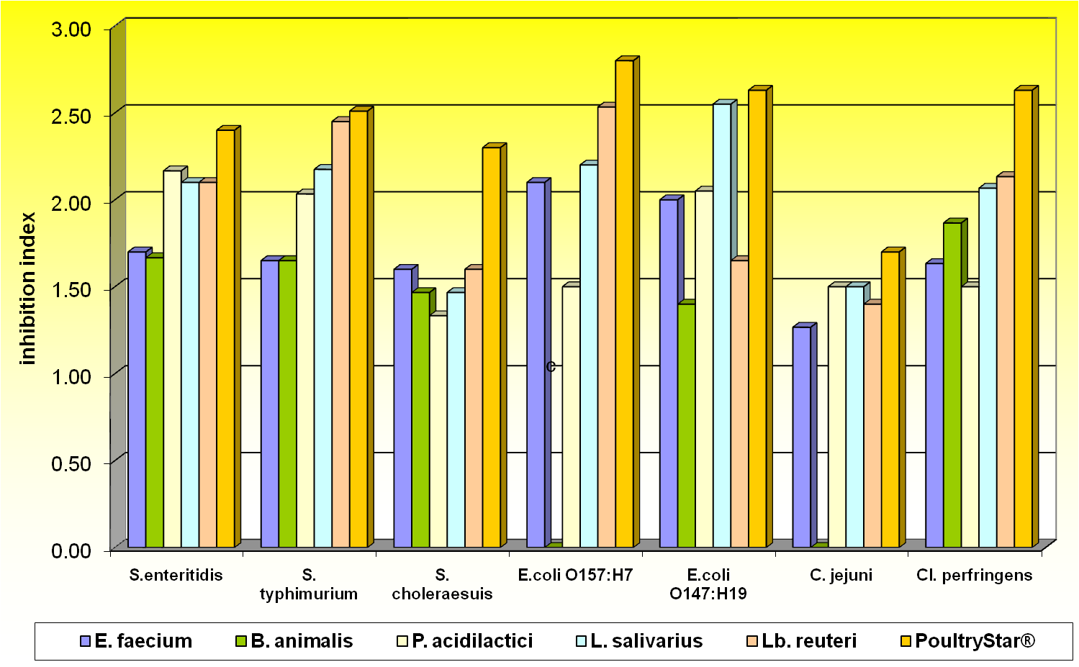

Essential oils and antibiotics
Essential oils (EO) are originating from extracts of herbs and spices. They can be natural., synthetic and contain one or several active molecules. Carvacrol, thymol, eugenol, cinnamaldehyde are some examples and they are known to provide antimicrobial., antioxydative and flavouring activities (Mathé, 1996). Moreover, it has been speculated that EO stimulate digestive enzyme secretions (Lee et al., 2004).
Applegate et al. (2009) have shown that a blend of different oils and a prebiotic has enhanced the performance and health status of birds infected with coccidia (paracox vaccination). Mac Reynold et al., (2008) also showed that the same mixture was able to decrease the severity of a necrotic enteritis challenge. Sub-clinical coccidiosis and necrotic enteritis are two common problems on many poultry farms and both problems are also very linked. The use of this blend in complement to antibiotics (AGP or treatment) against necrotic enteritis can provide a complementary effect.
A supplementary effect that EO give to antibiotic is their activities on the digestive enzyme secretion and their ability to improve the absorption surface of the gut and the feed digestibility (Applegate et al., 2009). The following figure shows the efficacy of a blend of essential oils improving the weight gain and the FCR at 37 days (Primex SAS Research Station, France, 2009).
 | Control | Biomin® P.E.P.
Mortality (%) | 2.5 | 2.6
Final BW (g) | 2059^{A} | 2104^{B}
Daily weight gain (g) | 54.5^{A} | 55.7^{B}
Feed intake (g) | 3669 | 3660
FCR | 1.82^{b} | 1.78ª
a,b Statistical significance (P<0.05), A,B Statistical significance (P<0.1)
Organic acids and antibiotics
Organic acids are a relevant tool to manage the feed and water hygiene. Beside these two main functions, organic acids can reduce the pH of the digestive tract, can lower the bacterial count in the gut and act essentially on gram negative bacteria such as Salmonella and E. coli (Roth et al., 1995). Chaveerach et al. (2004) concluded that organic acids added to the water could at least reduce the transmission of Campylobacter in a flock. To limit the proliferation of bacteria in the water, lowering its pH is also essential to control.
Through their action on the hygiene, organic acids are a good solution to support the bactericidal effect of AGP in the gut. Moreover, their strong action on gram negative bacteria is a complementary solution to antibiotics such as bacitracin and tylosin, which have mainly a gram positive spectrum. While treating a specific disease, it is also logical that water and feed hygiene should still be under control. Nevertheless, the water applicable antibiotics have an optimum pH for a good efficiency, therefore the organic acid application should be driven considering this.

CONCLUSION
Despite the fact that NGP are mainly positioned as substitutes by comparing to antibiotics, it is important to consider the potential combination of NGP and antibiotics, as growth promoter, prevention or treatment. Even if the use of NGP is well accepted, the ban of antibiotics does not lead necessarily to less use of antibiotics overall (DANMAP Report, 2007; MARAN Report, 2007). Resistance in animal is and will be of concern so if more NGP are included to poultry feed, it will be well accepted by the politics and the consumers. It has also to be added that NGP have not shown bacterial resistance or undesired residues in animal products.
By applying a well though-out strategy, complementary and supplementary effects of NGP can be added to the effect of antibiotics. Antibiotic overuse and some treatments could be saved by applying this strategy.

References
- Applegate et al., 2009. Effect of an essential oil blend on broiler performances, health status, gut histology and immunity. Not published yet, run in 2009 at the Center for Applied Nutrition from Biomin.
- AVCARE Report, 2003. The role of enteric antibiotics in livestock production.
- Cervantes H., 2009. 1st Watt Online conference.
- Chaveerach et al., 2004. Effect of organic acids in drinking water for young broilers on Campylobacter infection, volatile fatty acid production, gut microflora and histological cells changes. Poultry Science. 86 : 330-334.
- DANMAP Report, 2007. Use of antimicrobial agents and occurrence of antimicrobial resistance in bacteria form food animals, foods and humans in Denmark.
- Fuller R., 1989. Probiotics in man and animals. Journal of Applied Bacteriology, 66 : 365-378.
- Griggs J.P. and Jacob J.P., 2005. Journal of Applied Poultry Research, 14 : 750-756
- Lee K.W. et al., 2004. Essential in broiler nutrition. International Journal of Poultry Science. 3 : 738-752
- MARAN Report, 2007. Monitoring of antimicrobial resistance and antibiotic usage in animal in Netherlands in 2006/2007.
- Mathé A., 1996. Essential oils as phytogenics additives. In : 27th International Symposium on Essential Oils : Essential oils Basic and Applied Research. Ed. By Franz et al., pp 315-321. Allured Publishing Corporation, Vienna, Austria.
- McReynolds J. L., J. A. Byrd, R. Beltran, and D. J. Nisbet, 2008. Evaluation of probiotic and phytogenetic products on the development of Necrotic enteritis in poultry. International Poultry Scientific Forum, January 21-22 2008, Atlanta, USA, abstracts of papers p. 28
- Mohnl M. et al., 2006. Biomin internal data and : Development of a competitive exclusion product with defined cultures and its efficacy on reduction of S. Enteritidis in broiler. Oral presentation XII European Poultry Conference, 10-14 Sept 2006, Verona, Italy
- Mohnl M., 2006. Effect of a multi-strains probiotic on performances. Biomin Internal trial run at the Texas A&M university.
- Perdigon G. et al., 2001. Lactic acid Bacteria and the effect on the immune system. Current Issues in Intestinal Microbiology. 2 : 27-42
- Roth F.X. et al., 1995. Zum Einsatz von Ameisensaüre in der tierernährung. 5th Forum Tierernährung, BASF AG, Ludwigshafen, Germany. Pp 5-20.
- Steiner T., 2006. Managing Gut Health, NGP as a Key to Animal Performances. Ed. Nottingham University Press.
- Woodward P., 2005. 32nd Annual Carolina Poultry Nutrition Conference.

