Gut Health; a way to optimise egg layer development.

Andrew Robertson, Poultry Technical Manager, Biomin GmbH.

The performance of brown egg laying hybrids, and similarly white egg layers, has increased significantly through genetic selection over the last quarter century. The increase in productivity has been developed through advancing sexual maturity, increasing the level and time of peak production, improving persistency and also improving livability. An example of performance development during this time is demonstrated in the breed standards for Shaver 579 from 1985 and 2009.

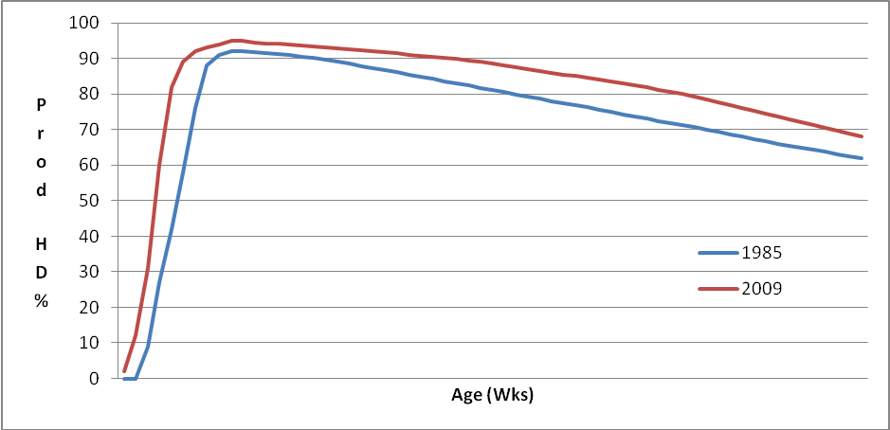
Figure 1. Shaver 579 standard production curves 1985 and 2009.
 | 1985 | 2009 | Difference
Livability (%) | 91.0 | 94.2 | +3.2
Age at 50% prod´n (d) | 157 | 145 | -12
Peak Prod´n (%HD) | 92 | 95 | +3
Age at Peak prod´n (d) | 189 | 189 | =
Hen Housed Average | 311 | 349 | +38
Av. Egg weight (g) | 66.5 | 63.2 | -3.3
Total Egg Mass (kg) | 20.674 | 22.057 | +1.353
Av Feed Consumption (g/d) | 121 | 114 | -7
FCR (kg feed:kg egg) | 2.55 | 2.22 | -0.33
Bodyweight at 80 weeks (g) | 2400 | 2000 | -400
Table 1, performance standards for Shaver 579 1985 and 2009.
Today’s performance could have been further improved by continuing advances in early maturity; however it has been recognized that the potential benefit in egg numbers may have come at the cost of ease of management and average egg size. For this reason most breeding companies have reduced or ceased selection in this characteristic and rely more on the improved post peak persistency to give continuing annual gains in egg number.
There remain two critical times in the life of the pullet which will have the greatest effect on final performance, the first four to six weeks and the time from onset of lay until peak production. During both these times body weight development is crucial if the flock is to perform to breeder standards. The period from day old to six weeks is also a period where the birds suffer varying stresses; particularly the start of the vaccination programme and when beak trimming it is carried out,
Despite intensive research in the areas of nutrition, feed presentation and lighting programmes many producers still encounter difficulties in achieving the breeder’s projected target weight at 4 weeks of age. Areas of advancement have come in improving the nutritional balance, both amino acids and energy in the early growing period. Research has shown that there is a direct effect between the energy level of the ration and growth rate in the early stages, as at this time the birds are unable to regulate energy intake to the energy level of the diet (ISABROWN Management Guide).
Any reduction in the amino acid content of the feed will lead to a reduced early growth rate (Bougon 1997). With the objective of maximizing growth during this initial period the amino acid balance of the feed is similar to that of a broiler of the same age. Birds, being primarily seed eaters, require a feed which is of a particulate form rather than a finer mash to improve consumption levels. Feed particle size has a direct impact on early growth rate, not only during the early brooding period but throughout the rearing period (ISA /CNEVA 1996)
Natural growth promoters (NGP’s) are already widely used in broiler production and field trials have also shown that the use of probiotics and / or phytogenics through the improvement of gut health can further aid the development of early growth in order to achieve the required early development. Examples of early growth improvements, to 42 days, in broilers with the use of Biomin PoultryStar® and Biomin PEP® are shown in table 2.
Product | Test Location | Increase in bodyweight
PoultryStar® | Gödöllö University, Hungary | +71g
PoultryStar® | Centro Ricerche per Zootecnia e l’Ambience, Italy | +81g
PEP® | Primex SAS, France (37 days) | +55g
PEP® | University of Novi Sad, Serbia | +75g
Table 2. Broiler results using Biomin PoultryStar® and Biomin PEP®.
The second critical time for successful performance is the period between onset of lay and reaching peak egg mass production. In nature a chick hatched in one spring would not come into production until the following year, therefore allowing it time to reach its adult weight before coming into lay. With current management programmes and light stimulation modern hybrids reach sexual maturity much earlier and whilst already in egg production still have to grow a further 20% to reach mature bodyweight. Again this means that care has to be taken in providing the correct nutrition for body maintenance, egg production and growth (Schutte et al 1994, NRC 1994).
Growth is the first parameter to suffer when insufficient nutrition is provided which will result in a lower 30 / 32 week bodyweight which, in turn, will affect post peak egg weight and total egg mass output (Lohmann Brown Management Guide). In order to overcome this early lay feeds have been developed to satisfy this need for increased protein between onset of lay and peak production. Nutrient utilization through improved gut function has been seen to improve early egg weights and feed efficiency without loss in growth with the inclusion of both probiotic and phytogenic products in the feed (BARC 2007, University of Novi Sad Trial 2009, Slovak Agriculture University Trial, 2004).
Birds are influenced by day length both during the early brooding period and also during the stage approaching onset of lay. A delay in reaching the rearing day length plateau will result in delaying sexual maturity. Similarly the time of increasing day length will have an effect on stimulation of sexual maturity (Lohmann Brown Management Guide).
Despite the ongoing developments the birds remain very adaptable to management changes in order to optimise the flock performance characteristics in egg number and egg size to meet the prevailing market requirements. Throughout the last quarter century producers have recognized the need to produce the correct egg size to meet the market requirement and have been able to amend their management practices to achieve this. Body weight at point of light stimulation has a direct influence on the future performance of the flock in regard to average egg size (Lewis 1987; Summers and Leeson 1985).
One of the consequences of this improved productivity is a reduction in the time between successive ovulations. Traditionally chickens when in production ovulated approximately every 26-27 hours, however with modern hybrid production this period has been reduced to between 24-25 hours with high production birds ovulating every 24 hours. The time from ovulation to the time the egg enters the shell gland has remained the same and the reduction in overall time between ovulation and lay has come from a reduced calcification time of the egg in the shell gland from approximately 12- 13 hours to approximately 11- 12 hours.
Calcium metabolism has needed to improve to counteract the reduced time in egg shell formation. Much research has been carried out in finding the best sources of calcium carbonate for egg production particularly in regard to solubility (Zhang et al 1997, Cheng and Coon 1987). Eggshell production is carried out predominantly at night in brown egg layers which means that the source of calcium has to be held in the bird’s crop and gizzard at the time of lights off. Faece examination has shown a high percentage of calcium particles of less that 1mm passing through the bird which has suggested that the gizzard will only retain particles of a larger size (Zhang et al 1997, Rao and Roland 1989, Boitumelo 2004). Hence the recommendation that limestone of a size 2-4mm is provided in the feed.
Improved gut function through maintenance of gut structure has a role in the calcium metabolism for eggshell production resulting in improved calcium digestion and absorption. Field trials have shown that the inclusion of either probiotic or phytogenic products have resulted in improved eggshell quality, which could see a reduction in the numbers of eggs being downgraded.
Feed costs amount to approximately 70 - 75% of the total cost of egg production; therefore any improvements in feed utilisation will have a direct impact on commercial egg production. The breeding companies are continually working in this regard and as a consequence final bodyweights have reduced significantly during the last quarter century. This has led to a 13% improvement in feed efficiency. However in order to maintain the correct egg size to meet market requirements further reductions in final bodyweight are unlikely or will be very small. It is therefore important to look at further ways to enhance feed utilization throughout the production period.
Many pathogens such as E. coli and Salmonella enteritidis can have a negative effect on gut structure, severely damaging the villi in the small intestine which reduces the ability of the gut to absorb nutrients. With Salmonella enteritidis this is particularly in the first two weeks of life. Control of these pathogens will improve overall feed utilization and acidification of either feed or water has been seen to be effective in both the control of Salmonella enteritidis and also improving overall productivity due to improved nutrient availability. Similarly in challenge tests with Salmonella enteritidis, PoultryStar® has been shown to significantly reduce the count per gram of cecal content (Sao Paulo State University, School of Agriculture and Veterinary Science Jaboticabal).
Having already achieved huge advances in productivity over the last 25 years what of the future? There is still scope to further improve overall egg productivity through continuing improvements in post peak persistency. However in today’s consumer led marketplace egg quality through shell colour and quality, haugh units and hygiene play as important a role to the producer as total egg number. For this reason breeders have placed increased pressure in these characteristics to improve the total numbers of saleable eggs rather than total eggs. This has led to improved depth and uniformity of shell colour for longer periods, improved eggshell quality and better maintenance of haugh units through the laying period.
Improving intestinal health and function is an area where little research has been carried out in layers, due to the length of time required for such testing. However, in trials that have been carried out in layers, as in broiler production, significant improvements have been seen with the use of probiotic and phytogenic products in regard to growth, feed efficiency and overall productivity. Use of these products as standard in the diet can help egg producers increase productivity of saleable eggs and achieve the standards available through many years of genetic development by the breeding companies whilst maintaining, or further increasing, feed efficiency. There is today an opportunity to improve layer performances by using the range of feed additives available.
References:
Boitumelo P.T. (2004) “ Influence of limestone particle size in layer diets on shell characteristics at peak production”, University of the Free State.

BARC (2007) “The use of NGP’s in commercial layers during the first period of the laying cycle. Biomin trial.

Cheng TK and Coon C (1987) “Effect of limestone solubility on layer performance and shell quality”, Poultry Sci 66.81

“Effect of PoultryStar® on cecal colonization of Salmonella enteritidis in broiler chicken.” Sao Paulo State University, School of Agriculture and Veterinary Science Jaboticabal

ISA Brown Management Guide 2009 - 10 edition.

Leeson and Summers; Poultry Science 64 1617 – 1622 1985.

Lewis P.D. et al (1996); “Effects of constant and changing photoperiods on age at first egg and related traits in pullets”, Br.Poult Sci 37, 885 -894

Lewis P.D. et al (1998); “A model for the effect on constant photoperiods on the rate of sexual maturation in pullets”, Br. Poult Sci 39, 147 – 151

Lohmann Brown Management Guide 2007 edition.

NRC, National Research Council (1994), “Nutrients required for poultry”, 9.ed Washington DC USA.

Rao K.S. and Roland D.A (1989). “Influence of dietary calcium level and particle size of calcium source on in vivo calcium solubilisation”, Poultry Sci 68 1499 – 1505

Roland DA Sr. (1986): Eggshell quality IV “Oyster shell versus limestone and the importance of particle size or solubility of calcium source.” World Poult. Sci. J. 42, 166 – 171.

Schutte et al (1994) “Requirements of the laying hen for sulphur amino acids”, Poultry Science. 73: 274 – 280

Slovak Agricultural University (2004) “Investigation of the effects of Biomin® IMBO on basic production in laying hens.” Biomin Trial

University of Novi Sad (2009) “Influence of NGP’s in commercial layers.” Biomin Trial.

Zhang B and Coon C.N. (1997) “Improved in vitro methods for determining limestone oystershell solubility”, Appl. Poultry Res. 6, 94 - 99

