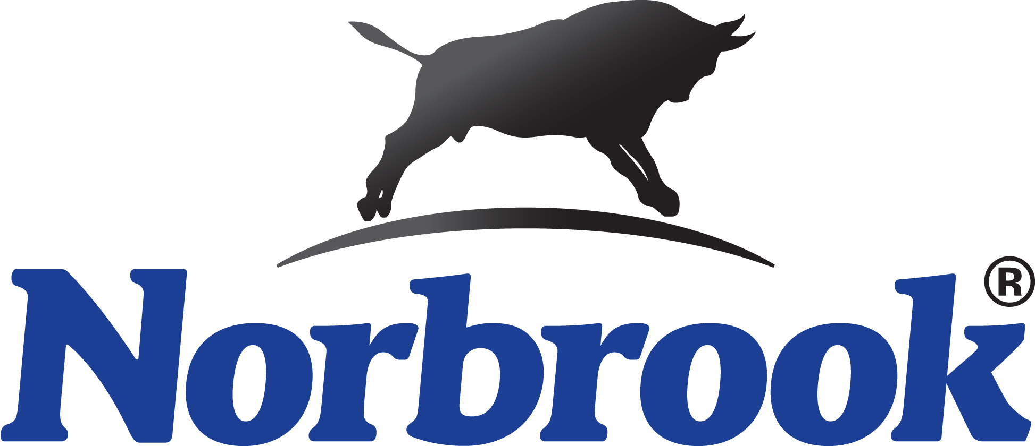

Hexasol Provides Low-Cost, Highly Effective Answer
To Problematic Pneumonia

“Hexasol is long overdue here in U.S. beef production,” states Dr. Bill Baus, Animal Health Center, Redfield, SD. “The product combination of oxytetracycline and flunixin has been available in Europe for nearly two decades and U.S. veterinarians have been asking for it in the U.S. market. And when it comes to Bovine Respiratory Disease (BRD) associated with pneumonia and fever, Dr. Baus reaches for new Hexasol® Injection instead of the high-priced, broad-spectrum alternatives like Resflor Gold®, Nuflor® or Draxxin®.
According to Dr. Baus, Hexasol has not disappointed him to date. “In fact,” he states, “Hexasol has proven to be an excellent, highly economical and highly effective choice when we don’t need to spend 20% to 50% per dose more for an antibiotic.
“For most of what our beef producers see, Hexasol fits extremely well,” Dr. Baus continues. “Because this is a single dose product, we know we’re giving the animal the best chance to break the infection.”
Dr. Baus prefers to choose a product that only requires a single dose. “If we have to come back in four to five days to give the required second dose of a product, we know that it rarely gets done. That’s why it’s pretty important that the first dose works.”
Dr. Baus notes that with Hexasol he gets a stronger, more potent dose of oxytet per mL, but it is the anti-inflammatory that really has him excited. “The anti-inflammatory in Hexasol quickly reduces fever so animals feel better much quicker and allows them to speed recovery and get back on feed much
quicker,” Dr. Baus notes. “The quicker we get them over infections, the better they’ll perform. Having the anti-inflammatory aspect available in Hexasol certainly makes the difference between a healthy animal and a re-treat.
Controlling the side effects brought on by a high fever certainly makes a difference on closeouts.”
Another advantage Dr. Baus points out is that Hexasol can be administered SQ. “That’s important – especially when you look at beef quality assurance issues,” he notes.

Feedlot Vet Sees Similar Results
“We are starting to see more feed yards use this oxytetracycline/flunixin combination product on incoming animals,” says Dr. Zach Smith, Dimmitt Veterinary Clinic, Dimmitt, TX. “This product has proven quite economical and extremely effective for treating/managing BRD-related pneumonia issues in these long-haul animals.”
Dr. Smith has really been impressed to date and likes the low-cost alternative to the top-shelf antibiotics. “While we still have no problem reaching for the more expensive products if necessary, this product seems to be handling the common issues we see in these stressed calves, and we can offer it at a much lower per-head cost,” Dr. Smith concludes.

Producer Impression
Fourth generation rancher Dave Hamilton and his wife, Loretta, own and manage the Reed Hamilton Ranch in Thedford, NE. The ranch has been in Hamilton’s family since 1898 (114 years). Hamilton, a past President of the Nebraska Beef Council (2009-2010) currently serves on the Nebraska Cattlemen’s Board of Directors. He oversees an 1,100-head commercial Simmental/Angus cross beef operation in the Sandhills region of Nebraska and was excited when the one-dose product became available.
“When we start calving in April, we are on the pastures three-to-four times a week looking for signs of pneumonia like snotty noses, loss of appetite, calves that carry their heads down and slow movement. If we see any of these signs, we quickly administer a SQ dose of Hexasol Injection.”
Hamilton says they have been using the two main components that make up Hexasol – oxytetracycline and the anti-inflammatory flunixin – for several years. The only issue he’s had in the past is they had to use two separate injections to get both products into the calf.
“That has always been an issue on the ranch, because we don’t like to inject the calf that many times,” Hamilton states. “However, it has always been the best treatment for early, mild pneumonias. Hexasol has eliminated our two-dose issues to fight pneumonia and other stress issues. We’ve been extremely pleased with its per-head economics (around $5/head for a 500-lb. calf), ease of SQ administration and level of control.”
According to Hamilton they inject a single SQ dose of Hexasol at the first sign of respiratory issues. “Perhaps the biggest advantage that we see with this one-dose product is that the anti-inflammatory in the product quickly breaks any fever in the calves,” he notices.
“In the past we have seen fever cause some lung damage in infected calves. That’s why we’ve always incorporated an anti-inflammatory in our pneumonia treatment protocols. We routinely perform sensitivity tests and if the bug we’re looking at is sensitive to oxytet, this is the most economical choice for us to use. It all comes down to the practicality of giving one-shot vs. two. We routinely reach for Hexasol as a first step.”
Hamilton also notes that in the past when effective treatments required an IV type product to break the fever, it would mean bringing the animals back to the treatment area for several days.
“With the Hexasol SQ dose, the calf can go right back on the cow, or if it’s weaned, it can get back to eating and growing,” Hamilton concludes. “It’s extremely nice and efficient not to have to sort them and bring them back to the treatment areas. In just a short time it has helped eliminate a lot of labor and animal stress.”

