June 17, 2009

Memo to: Kathleen McLaughlin, Sue Roberts, Jessica Bond
From: Bruce Plantz
Re: Newsletter click throughs

We have good reporting software in Exact Target, where we can see each item and the percentage of click-throughs it got. I’ve asked Andy to get you each set up with passwords and instructions so you can see these reports. We should be looking at these almost weekly, to see what is working and what isn’t.

What I’m looking at in these is the items pushing people to the community, and what works and what doesn’t.

First, the “Join our Community” approach. While we might like it, the percentage of click-throughs was low.

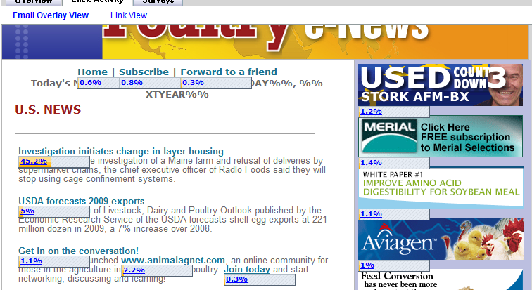

Here’s an example from this week, which took a topic and made a news item. No mention of community. The result was a much higher number “We must communicate the positives.

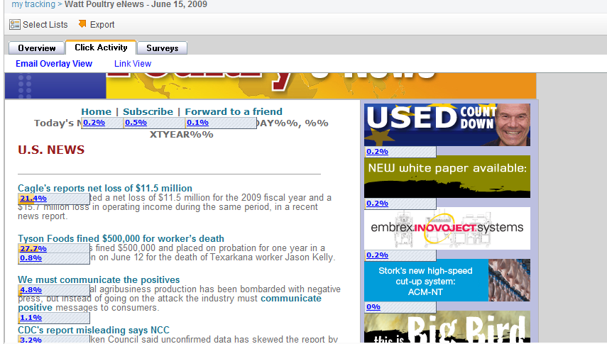

Here’s an example from last Tuesday, that I really, really didn’t like. Yet it was effective. That shows how much to value my opinion.

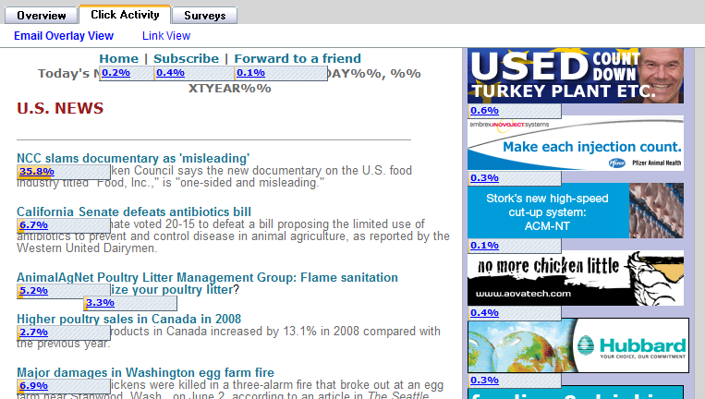

Here is an example from Egg Industry Insider. It had an active headline, and we got over 7 percent click-through on the item.

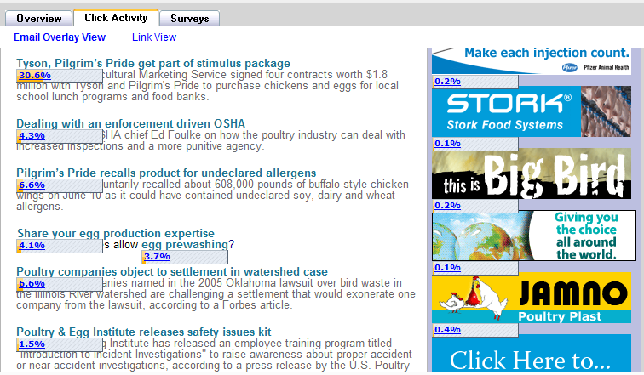

And do the logos at the bottom of the page work. Yes.

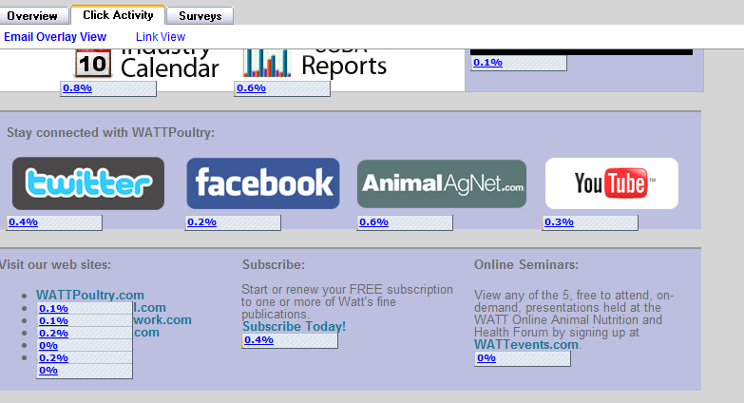

Here’s yesterday’s PetFood newsletter, again with a story that takes you into the community. Click-through rate was good.

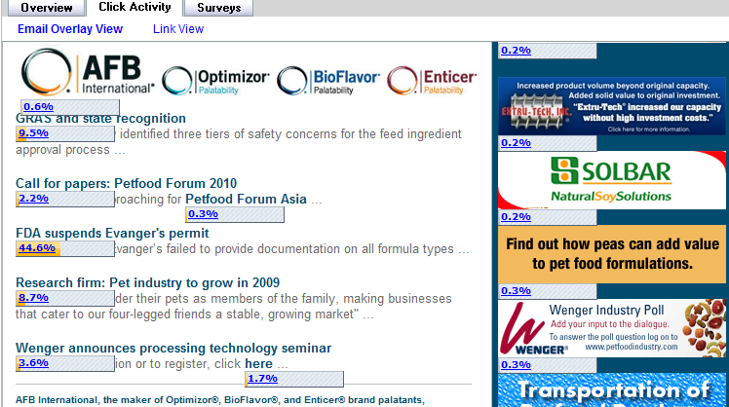

The moral of all this? Look at every newsletter, and let’s make sure what we are doing works. We have to tools to do this, let’s use them.

