Hygiene control and benefits for poultry, egg producers

Reducing bacteria levels not only reduces disease risk, but can boost productivity

Regular use of Stalosan F in all animal housing improves sanitation standards, lowers the disease level and increases both condition of life and feed conversion rate. Benefits of using Stalosan F for breeders and layers are comparable to that experienced with other food-animal species.

Stalosan F can be spread in the facilities with the birds present, with no risk at all for them, as frequently as the management thinks is necessary to sustain the level of health and well-being of the birds. Animal caretakers, responsible for spraying and their families should benefit from the reduced aerosol load of microbes within the environment. Stalosan F is efficient in killing microbes, viruses, insect larvae and it also gives the opportunity to rid of the premises of other toxic materials. The result might be from reducing a single pathogen, but often from reducing a group of pathogens.

Such a response reported in a grower study at Shropshire Farms UK with 40,000 turkeys per treatment. Treatments consisted of (1) a control in which rooms were cleaned and disinfected and (2) the treated group that in addition received programmed spraying of Stalosan F.

After 5 weeks, mortality was 30% less when Stalosan F had been provided. In addition, medications were 80% lower for turkeys that had benefit of Stalosan F.

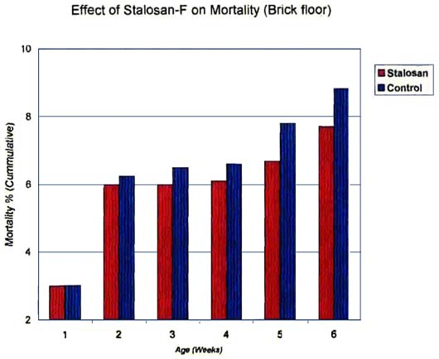
Imran, Chang-Magna, and Aleem reported similar reductions in mortalities for broilers with programmed use of Stalosan F in broiler houses. Stalosan F is an effective continuous-use disinfectant.

At Purdue University we worked with large layer farm - 22 million layers in production.
•Addressed problem of elevated bacterial count on eggs transported by belt to process area.
•Eggs move few hundred meters through corridors across ends of buildings.
•Each building contains about 60,000 layers.
Aerial view is of laying complex where Stalosan F was sprayed in belt end of room.

Sprayed for 4 successive weeks, Bacterial test for 8 successive weeks in presence of 60,000 layers
Effect of Stalosan F on Aerobic Plate Count in Layer House

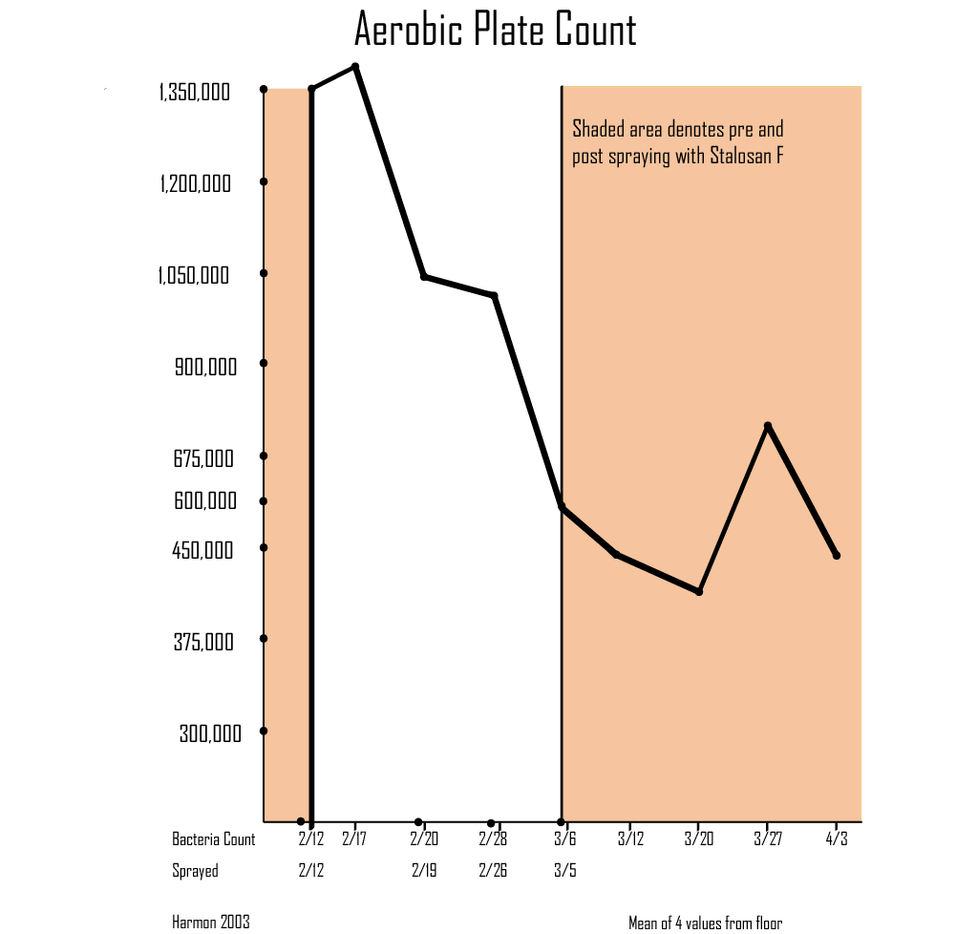

Effect of Stalosan F on Coliform Counts in Layer House

Poultry are quite susceptible to coccidian
• Stalosan F quite effective in reducing fecal count of this protozoan parasite
• Parsons has shown effects on the count of oocytes in fecal matter from pigeons
• Initiated spraying of Stalosan F in a continued use building

In a building that had been in use for an extended period, the oocytes per gram dropped from over 3,000 to less than 1,000 after 2 treatments

Air Quality

With reduced microbial activity and increased desiccation, the quality of air with rooms will be improved.

• The gasses most likely to reach a level to compromise health and well being are ammonia and sulfides.
• Stalosan F reduces microbial metabolism that generates and releases the 2 gasses.
• Shropshire Turkey Farm has shown the effectiveness of Stalosan F in controlling ammonia over the first 5 weeks of production. Ammonia levels were 3 times
greater in the control treatment .

Stalosan F Improves Weight Gain and Feed Efficiency

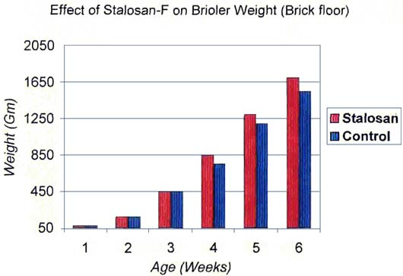
• Healthier birds will increase gain and feed efficiency.
• Stahly showed that the less amino acids utilized to produce immune globulins, the greater amount
available for protein tissue deposition.
• Greatest increases in food animal growth in past decade came from increased emphasis on herd
health.
• Many studies to choose from to demonstrate the benefits in growth from the programmed use
of Stalosan F in the hygiene program.
• Imran et.al. from Pakistan have conducted studies comparing hygiene programs with and without
Stalosan F in broiler growth studies

The most striking visual and economic benefit from the use of Stalosan F is the action of multiple features that result in reduced mortality and morbidity. This is the ultimate contribution to animal welfare and well being.

Stalosan F is used by numbers of animal genetic companies as a first line of defence to improve bio security and safety from disease entry into production units, including spraying Stalosan in all entry approaches into buildings and the material in footbaths. Also some zoos use Stalosan as a part of bio security prophylactic measures to minimize the spread of diseases. The use of Stalosan continues to grow because of testimonials and researches that showcase the multiple biological benefits and economic advantages to the programmed use in poultry production facilities.

Considering the high investment in breeding stock, Stalosan provides a valuable source of insurance. Stalosan is both economic and biologic safeguard for meat and egg production. The incorporation of programmed Stalosan treatment into food-animal production practices simplifies management, improves performance, enhances flock health, enhances human health, improves the environment, secures animal welfare, and insures greater bio security.

